**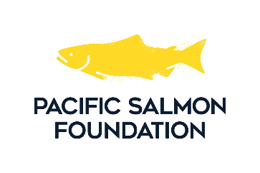  
2025/2026  
Salmon Conservation Stamp   
Art Competition**

## ENTRY REGISTRATION FORM

I have read and understand the attached specifications for the Salmon Conservation Stamp and Print Competition and intend to enter the competition. I agree to comply fully with the rules of the competition   
as contained herein.

Artist Name (please print):

Artist Signature:

Date: ______________________________

Name of Painting:

Description:

Medium:

Mailing address:

Phone:

Email:

Shipping address:

(If different from above)

**All artworks must be received by 4:00 p.m. on Thursday, October 31, 2024**  
Please send completed form with artwork to:

Pacific Salmon Foundation  
Attn: Bailey DeBaie  
320 – 1385 W. 8th Ave.  
Vancouver BC, V6H 3V9  
Email: [bdebaie@psf.ca](mailto:bdebaie@psf.ca)