May 30, 2025

Dear Artist,

It is our pleasure to extend an invitation for you to enter the 2026/2027 Salmon Conservation Stamp Art Competition.

This year marks the 38th annual Salmon Conservation Stamp Art Competition and the winning image will be selected to produce the 2026/2027 stamp. Fisheries and Oceans Canada issue the Salmon Conservation Stamp, which is purchased and affixed to the license of tidal water anglers who wish to retain any species of salmon.

Please read through the enclosed rules and regulations carefully. We hope to make it clear that we encourage and welcome representational images such as First Nations art and that not all entries will include traditional habitat backgrounds. Please note that the winning artist may not enter the competition for two years following the year that they win the competition. Also of note, PSF is not responsible for any brokerage fees and customs charges for delivery to and from the USA.

Should you know of anyone who would like to enter this competition, please inform our office or forward this information to them. You may also direct them to www.psf.ca for more information.

All artworks must be received at the Pacific Salmon Foundation office below no later than 4:00 p.m. on
Friday, October 31, 2025.
Pacific Salmon Foundation
Attn: Bailey DeBaie
320 – 1385 W. 8th Ave.
Vancouver BC, V6H 3V9
Email: bdebaie@psf.ca
The competition will be held on a date to be determined this November. Specific details to follow. We hope that you are able to enter this year!

Sincerely,
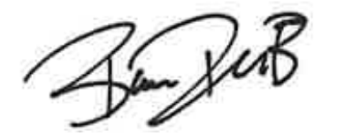
Bailey DeBaie
Coordinator, Events

