**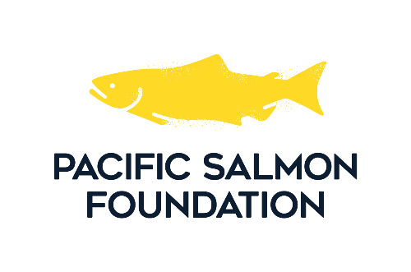  
2026/2027 Salmon Conservation Stamp   
Art Competition**

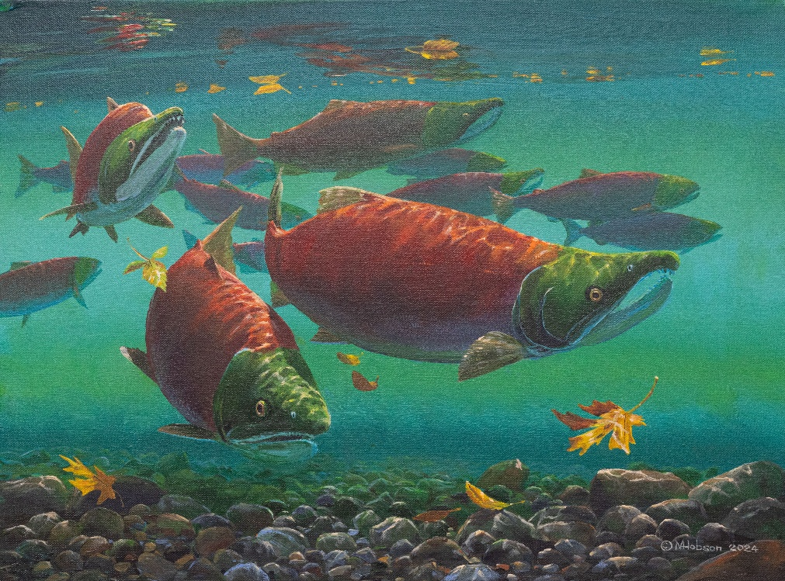

**“RED OCTOBER” by MARK HOBSON.   
2025 – 2026 salmon conservation stamp winner**

**TABLE OF CONTENTS**1.0 Pacific Salmon Foundation Overview  
2.0 Salmon Conservation Stamp Art Competition History   
3.0 Competition Rules  
4.0 Judging Criteria & Specifications

**1.0 Pacific Salmon Foundation overview**

The Pacific Salmon Foundation (PSF) is a non-profit environmental organization dedicated to the conservation and restoration of wild Pacific salmon and their habitats in B.C. and the Yukon.

For us, it’s salmon first, salmon always and we never go it alone. We work with First Nations, Government, ENGO partners, industry and all people for salmon who share the desire to save and restore these iconic species.   
  
More than half of Pacific salmon populations are in decline. Some are facing extinction. Climate change is their greatest threat, but it’s not too late, we can help.

With more than 300 community partners, we can advance game-changing research, habitat monitoring and restoration, and help salmon overcome a myriad of challenges.

Each year, PSF works with Fisheries and Oceans Canada to produce the Salmon Conservation Stamp. Any angler wishing to retain any species of salmon must purchase and affix a Salmon Conservation Stamp to their tidal waters sport fishing license. Since 2013, 100% of the revenue from the sale of these stamps is returned to BC to fund salmon restoration and enhancement projects supported by PSF through its Community Salmon Program.

The Salmon Conservation Stamp image is used as an additional fundraising source for PSF with the production of limited-edition art prints.

**2.0 salmon conservation stamp art competition history**

The original stamp agreement between Fisheries and Oceans Canada (DFO) and PSF was established in 1987. The Salmon Conservation Stamp (originally, Chinook Conservation Stamp) was established in 1989 as part of the 1989/90 – 1990/91 Contribution Agreement with Fisheries and Oceans Canada to develop and manage a “conservation stamp” program in conjunction with DFO’s sport fish licensing program.

The Salmon Conservation Stamp is issued under the Fisheries Act by the Minster of Fisheries and Oceans Canada pursuant to the BC Sport Fishing Regulations as a means of promoting conservation, restoration and enhancement of the salmon resource and salmon habitat.

In past years, PSF received approximately 20% of the income from the salmon conservation stamp with the balance retained by the Federal Government of Canada. However, in 2013 PSF successfully negotiated the full 100% return of the stamp income to BC for salmon restoration and enhancement.

**Salmon Conservation Stamp Details**

* Pacific Salmon Foundation annually manages a competition to select an original image to be reproduced as the Salmon Conservation Stamp for the next angling season
* Fisheries & Oceans Canada will be the exclusive client for the stamp throughout the year the stamp is used
* Pacific Salmon Foundation obtains and retains exclusive rights for the use of the stamp image.

**Past Winning Artists**

**Year Artwork Title Artist**

1989 Chinook Salmon Robert Field

1990 Chinook Salmon Bruce Muir

1991 Rivermouth Squabble Curtis Atwater

1992 Stamp River Falls Bruce Muir

1993 Chinook Salmon Luke Raffin

1994 Return of the King James Wiens

1995 Northern Coho Bruce Muir

1996 In Pursuit Stephen Wan

1997 Tyee Pool Bruce Muir

1998 The Chinook Returns James Wiens

1999 Surf Line Springs Sam Jackson

2000 Long Live the King Bill Munsie

2001 Hide and Seek Sam Jackson

2002 Searching the Shallows Bill Munsie

2003 Catching the Strays Mark Hobson

2004 Red Spring Bill Munsie

2005 Return to Fresh Water Mark Hobson

2006 High Tide Feed Bill Munsie

2007 Breaking the Surface Trevor Tennant

2008 "Sockeye" Pre-spawning Phase Bill Munsie

2009 The Choice Luke Raffin

2010 Surface Tension Mark Hobson

2011 A Moment of Action Curtis Atwater

2012 Hunger Strikes Esther Sample

2013 River Run Bill Munsie

2014 Rapid Approach W. Allan Hancock

2015 Salmon Tale April White

2016 Flash of Silver Esther Sample

2017 Passing the Torch Nick Laferriere

2018 Settled In Donnie Hughes

2019 Race for Survival Tak Shoji

2020 Untouchable Joshua Hansen

2021 Chinook Salmon: Breaking Through Mark Hobson  
2022 On the Move Eric Jablonowski

2023 Rapid Ascent Valerie Rogers

2024 Pursuit Dale Cooper

2025 Red October Mark Hobson

**3.0 COMPETITION Rules**

**1. Artist Eligibility**

* All artists are eligible to participate by submitting artwork and an accompanying entry for by the competition deadline.
* Members and/or relatives of the competition judging panel, employees of Fisheries & Oceans Canada, and employees of Pacific Salmon Foundation are ineligible to submit an entry.
* Persons who have won the competition during the preceding year are ineligible to submit an entry for the following two years.

**2. Subject Matter of Submissions**

* The principal subject must be Pacific Salmon (singular or plural) of any species as listed below, depicted as the focal point: Chinook, Coho, Sockeye, Chum, Pink, Steelhead and Cutthroat
* As this is a Salmon Conservation Stamp and Print, the subject (salmon) must be clearly represented. Although there is no restriction on the degree of realism of the image, the selected species must be painted in accurate proportions and detail. Some styles of salmon art are not visually and anatomically realistic (i.e. North West Native Art). If this is the case, the image can be rated on the basis of its representational qualities and ‘accuracy’ in terms of its style type.

**3. Specifications for Submissions**

* The painting must be **unframed**, with optional white matting. PSF will not arrange frame removal or matting for individual artists. It must be of a horizontal design. Minimum acceptable size is 6.5” high by 9” wide. The maximum permitted size is 19.5” high by 27” wide. Submissions must be properly proportioned to accommodate the following reproduction sizes:  
   a) Limited Edition Print: 6.5” high by 9” wide  
   b) Conservation Stamp: 1.25” high by 2” wide
* Entries must be multicolored and may be painted in the artist’s choice of medium. Digital representations and computer-generated artwork do not qualify. All entries must be original paintings. Remember however, that the judges are looking for a painting that will reduce easily to stamp size. Submissions that are too dark or too busy do not translate well to stamp size as they can lose their clarity and detail when reduced. PSF will reproduce each image to stamp size and the stamps will be on display with the original entry for the judging process.
* Artists’ initials and/or name may appear only on the bottom right corner of the painting for the competition, but the artist hereby agrees that any form of identification will be covered over prior to and during the competition. Each entry will be identified by a number assigned by Pacific Salmon Foundation.
* The winning artist must agree to grant and assign all existing and future rights to the painting to Pacific Salmon Foundation, including, but not limited to, the artist’s copyright in the painting.
* PSF may choose to display all previous winners and all new entries in a public display before the competition.

**4. Submission Procedure**

* Each artist may submit only one original entry which must be accompanied by an artist’s entry form.
* Each entry should be protectively packaged and dropped off in person, mailed or shipped via courier. Pacific Salmon Foundation will return each entry in its original packaging following the competition.
* PSF will not insure paintings except from the day they are received and for seven days after the competition. Artists therefore should obtain adequate property coverage for their paintings. It would be appreciated if the artists could come by the offices of PSF within two weeks of the competition to collect their paintings. With the exception of the winning painting, all entries not picked up by hand will be returned, (in their original packaging) by priority post, courier or Canada Post (uninsured) within 30 days of the completion of the contest. PSF is not responsible for any brokerage fees and customs charges for delivery to and from the USA.

**5. Competition Deadline**

* All artwork must be delivered no later than   
  **4:00 p.m. on Friday, October 31, 2025 to:**

Pacific Salmon Foundation

Attn: Bailey DeBaie

320 – 1385 W. 8th Ave.

Vancouver BC, V6H 3V9

Email: bdebaie@psf.ca

**4.0 Judging Criteria and Specifications**A minimum of seven independent individuals will be selected by Pacific Salmon Foundation to serve without compensation as judges. Entries will be judged on the basis of:

* Representational qualities and habitat accuracy if applicable
* Artistic composition
* Originality
* Technical suitability for reproduction as a conservation stamp and lithograph print

There will be three scoring stages:

**First Stage**

Judges will view all entries together and then individually, to determine those that meet the basic requirements of artistic composition, originality and technical suitability for reproduction as a conservation stamp and lithograph print. Those entries deemed suitable will be moved to the second stage. There must be consensus that an entry not be moved to the second stage for it to be eliminated.

**Second Stage**

Each painting found acceptable in the first stage of judging will be displayed. Judges may discuss aspects of each painting using the following rating criteria and scoring system:

1. Biological Criteria (2 points maximum)

* Rate the accuracy of species anatomy or in the case of representational art, the quality of the representation
* Rate the accuracy of the habitat if the image includes habitat

Some styles of salmon art are not visually and anatomically realistic (i.e. North West Native Art). If this is the case, the image should be rated on the basis of its general representational qualities and ‘accuracy’ in terms of its style type.

1. Artistic Criteria (4 points maximum)

* Does the image present a fresh perspective?
* Rate the use of light, colour and form
* How well does the painting represent the subject?
* Is the level of detail appropriate and consistent within the painting?

1. Appeal Criteria (4 points maximum)

* Will the subsequent image appeal to a wide audience for use as a conservation stamp and limited edition print
* Will the painting reproduce to a 6 ½” x 9” print as well as a 2 ¼” x 2” stamp?

Each judge will vote scoring each entry from 0 to 10 based on the sum of the three criteria. The highest and the lowest score for each entry will be eliminated and the remaining scores will be totaled to indicate the score for that entry. The entries receiving the four highest scores will then advance to the final round of judging.

**Third Stage**

For the final round, all judges will vote on the four remaining entries using the same 10-point scoring system and criteria used in the previous stage. The winning entry will be the one receiving the highest score. Second and third place will also be chosen on the basis of ranking.

In the event of a tie for first place, all judges will vote on the deadlocked entries using one vote per judge for their preference. The winner will be the entry receiving the most votes. The judge’s decision will be final.

**None Suitable**

In the event that the judges, in their collective opinion, do not find an entry suitable for selection, Pacific Salmon Foundation reserves the right to commission an artist of its choice to produce the image.  
  
**Renumeration**

The remuneration for the winning artist will be $6,000 payable in two installments of $3,000; the first immediately following the competition and the second upon signing the number of limited-edition prints and stamps as required by the PSF.

PSF will award the artist who places second in the competition $3,000, and will award the artist who places third in the competition $1,500. These two awards will be presented immediately after the competition.