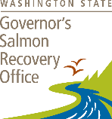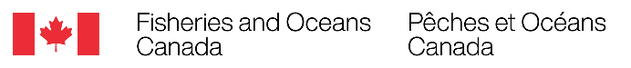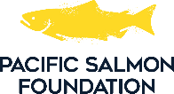

Opening the Gates: Solutions for Fish Passage and Flood Control

Virtual Knowledge Exchange Workshop Agenda

Sept 10th, 2025 ~ 1:00pm – 4:30pm PST

|  |  |
| --- | --- |
| 1:00 - 1:05 | **Moderators – Laura Weatherly (DFO), Greer Maier (GSRO), Jason Hwang (PSF)**  *Introduction and Welcome* |
| 1:05 - 1:35 | **Guillermo Giannico, Oregon State University**  *Tide gates and floodgates: All you wanted to know but never dared to ask* |
| 1:45 - 2:10 | **Jason Nuckols, The Nature Conservancy**  *Oregon’s tide gate journey: New solutions for tide gates, fish passage and working landscapes* |
| 2:20 - 2:30 | Break |
| 2:30 - 2:50 | **Dan Straker, Resilient Waters**  *Fixing Fraser floodgates for fish* |
| 3:00 - 3:30 | **Zachary Sherker, The University of British Columbia**  *Fish in the floodplain: Self-regulating floodgates to improve juvenile salmon access to critical overwintering habitat* |
| 3:40 - 4:30 | Panel Discussion |
|  |  |

Registration: <https://us02web.zoom.us/webinar/register/WN_nvEk60JgQWCFrZo8OpGmXA#/registration>