

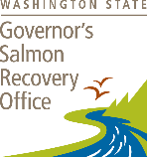
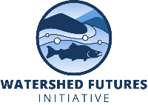
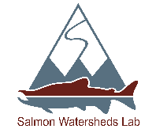

CUMULATIVE THREATS, COLLABORATIVE SOLUTIONS: SHAPING SALMON &
WATERSHED FUTURES
16 June, 2026 ~ 9:00am – 3:30pm PST
VIRTUAL KNOWLEDGE EXCHANGE WORKSHOP AGENDA

9:00-9:10 | WELCOME
9:10-9:25 | Jonathan Moore, Simon Fraser University  Cumulative Impacts as a Wicked Problem
9:30-9:40 | Nigel Sainsbury / Sara Cannon - Simon Fraser University  Values, Injustice, and Salmon
9:45-9:55 | Spencer Dakin Kuiper, Simon Fraser University  Spatial Patterns in Cumulative Impacts
10:00-10:10 | Sam Wilson, Simon Fraser University  Synthesizing Pathways of Effect for Decision Making
10:15-10:35 | Q & A – J. Moore, N. Sainsbury, S. Cannon, S. Dakin-Kuiper, S. Wilson
10:35-10:45 | BREAK
10:45-10:55 | Nigel Sainsbury, Simon Fraser University  Public Preferences for Watershed Stewardship
11:00-11:10 | Marta Ulaski, Simon Fraser University  Policy for Healthy Habitat
11:15-11:25 | Riley Finn, University of British Columbia  Action for Salmon Recovery
11:30-11:40 | Jonathan Moore, Simon Fraser University  Shared Watershed Pathways in a Time of Cumulative Impacts
11.45-12.15 | Q & A – N. Sainsbury, M. Ulaski, R. Finn, J. Moore
12:15-13:00 | LUNCH BREAK
13:00-13:05 | WELCOME BACK
13:05-13:30 | Urban Eberhart, Kittitas Reclamation District / Michael Garrity, WA Dept. Fish & Wildlife  The Importance of Collaboration in the Yakima Basin and Other Regions
13:40-13:55 | Christina Radyo, Skeetchesn Natural Resources  Tsecmenúl̓ecwem-kt: A Collaborative and Multi-Disciplinary Approach to Managing Cumulative Impacts in the Deadman Watershed
14:05-14:25 | Rene Henery, Trout Unlimited  Towards Coherence: Tactical Guidance for Working Differently
14:35-15:30 | Panel Discussion – U. Eberhart, M. Garrity, C. Radyo, R. Henery, J. Moore, M. Ned, L. Helmer

